Comparative Analysis of Responses to Different Caffeine Products Among
Individuals of Different Ages

Ryan Kim
MICA International School
Intensive Writing 9/10
Mr. Kohner Bouchard
June 7, 2026

Author Note
This research paper is written by Ryan Kim, a freshman at MICA International School. This paper lasted a semester writing a research article under the guidance of Mr. Kohner Bouchard. The raw measurements and the analysis code are shared together with this paper, so the numbers in this paper can be checked again.

Abstract
Today, caffeine is one of the most consumed stimulants in the world, and the growth of the energy drink market has pulled teenagers into the debate over whether it is safe for a developing body. This study compared the short-term responses to three caffeinated drinks, Seoul Milk Coffee, Hot Six, and a Starbucks caffe latte. Three participants drank 100 ml of one product per session and had their blood pressure and pulse measured for up to 60 minutes, followed by a self-reported alertness score. Because the participants did not start from the same resting blood pressure, every comparison uses the change from each participant's own baseline instead of the raw numbers. Checking the nutrition labels also showed that the caffeine of the three drinks per 100 ml was almost the same, with less than a 3 mg difference, even though this was not planned. At that matched dose, the latte produced the largest change in systolic pressure with an average of +15.3 mmHg, the pulse did not change after any product, and the alertness scores went in a different order, as the drink that felt the most stimulating produced the smallest measured change. These results suggest that the effect people feel from a caffeinated beverage may follow the product image more than the caffeine inside it, so consumers should check the caffeine printed on the label instead of judging by the category.

Introduction
Background and Context
This research paper plans to examine the physiological responses to consuming caffeine in different individuals. Today, caffeine has become one of the most consumed stimulants in the world. Other forms of stimulants include nicotine, cocaine, ephedrine, and more. From students to adults, this chemical has become an irreplaceable aspect of their lives. People started drinking caffeinated products to stay concentrated, reduce fatigue, and increase alertness. The popularity of caffeine in today's fast-paced society has brought many to rely on caffeine in order to remain productive and do all-nighters for specific days. As a result, caffeine consumption has been accepted in all age groups, even for teenagers and young adults.
The importance of studying caffeine consumption has increased over the past few decades, due to the rapid expansion of energy drink companies, along with growing concerns about their health effects from stressing the user's body. As an example, the Mayo Clinic publishes a daily limit for healthy adults exactly because so many people drink caffeine every day (Mayo Foundation for Medical Education and Research, n.d.). This evidence shows how much reliance on coffee is already set in our society.
Historically, caffeine was introduced as a product of coffee and tea, while the first text to mention coffee was a medication from the book, The Canon of Medicine, written in 1025 by a Persian physician. It has later been popularized, leading to caffeine consumption worldwide, with billions of cups of coffee consumed per year. But today, people take energy drinks such as Monster or Red Bull, changing the style of what caffeine used to look like, from a bitter fragrance, as a sweet, vibrant beverage. These products have not only increased in their spread but also in their styles, including famous soft drinks and energy drinks that teenagers drink day to day. Their targeting of younger, developing adolescents has successfully increased caffeine consumption. Plus, unlike traditional coffees, these products include additional stimulants such as taurine and guarana, along with high sugar levels, which intensifies the original effects, giving long-term health issues with excessive usage among younger populations.
Currently, based on research about caffeine, caffeine works by blocking the adenosine receptors in the brain (U.S. National Library of Medicine, n.d.), trying to stop any sleepiness resulting in the individual. Plus, adenosine is defined as the neurotransmitter that promotes relaxation and sleep. To move on, with a controlled amount of caffeine, it can support the user's work by increasing focus, improving reaction time, and enhancing cognitive performance.
However, drinking too much caffeine can still cause problems like other stimulants. Excessive caffeine intake, just like some of the other stimulants, may lead to some trouble, ending with problems such as increased heart rate, elevated blood pressure, and anxiety. Also, research today suggests that the sensitivity towards caffeine differs, almost completely, depending on factors such as age, metabolism, tolerance, and frequency of product consumption. As an example, teenagers are more sensitive to this stimulant because their bodies are still in development, and most of them have lower caffeine tolerance levels compared with adults.
Additionally, because of these negatives of caffeine, there are rising conflicts over caffeine consumption among teenagers. With their stages of development still ongoing, society questions whether intakes from a young age are ethically right and can be accepted. However, despite the large amount of research papers surfacing on online platforms today, there are still gaps remaining in the field. As an instance, many existing studies often examine adolescents or adults separately rather than directly comparing how different age groups respond to caffeine products under similar conditions. Also, another gap is that these comparative studies rarely show how much caffeine each product actually contains per volume, which makes it hard to tell if a difference between beverages came from the product itself or just from the dose.
The social parts of this issue have become more effective as caffeine consumption continues to rise among teenagers. Many adolescents consume energy drinks to improve their academic performance, awaken themselves for the night, and alert themselves to maximize their athletic performance. This brings us back to the course of debate considering caffeine's safety and regulation within scientific and public health communities. Some researchers argue that a moderate amount of caffeine may provide benefits. Others argue that the dangers associated with excessive intake of caffeine create stronger negative results with aggressive marketing of energy drinks to younger customers, with a questionable limit of caffeine for adolescents, that energy drinks act as a greater health risk than coffee, and how different caffeine sources affect cardiovascular functioning. In Korea, a survey by the Seoul Metropolitan Government found that coffee beverages in convenience stores contain 30 to 139 mg of caffeine per serving, which overlaps the 4 to 149 mg range of energy drinks, so the two categories are not even separated by their caffeine amount (Seoul Metropolitan Government, n.d.).
This study focuses specifically on comparing the physiological effects of energy drinks and coffee among teenagers and adults. Unlike the previous research that consisted only of the questionnaires, this research would find direct measurements, including heart rate, blood pressure, and self-reported alertness levels, with a comparison with the original state versus the state after caffeine consumption. By creating an analysis of these responses, this study aims to provide a more complete idea of how caffeine affects individuals. The direct measurements in this study were the systolic and diastolic blood pressure in mmHg and the pulse in beats per minute, taken for up to 60 minutes after drinking.
Research Problem
Although caffeine consumption has been normalized through different ages, not all opinions lead to the same conclusion. There is limited comparative research that examines how different caffeine products affect individuals, especially adolescents, among individuals of different age groups. Existing studies often focus broadly on caffeine consumption without separating it from different products like energy drinks or coffee. Furthermore, these forms of research do not include a clear separation for adolescents to adults, creating a lack of direct comparison regarding age-related physiological and cognitive responses. For example, a can of Hot Six and a carton of Seoul Milk Coffee sit in the same convenience store fridge, but few consumers would guess that their caffeine per 100 ml is only 2.5 mg apart.
These forms of problem gaps matter because caffeine consumption among teenagers has increased in recent years, through energy drinks that are advertised. Without clearer experimental evidence, many individuals may lack information about how these products affect heart rate, blood pressure, and alertness. In Korea, the suggested daily limit for adolescents is 2.5 mg per kg of body weight, so a 50 kg student reaches the limit at about 125 mg, which is less than two cartons of coffee milk (Seoul Metropolitan Government, n.d.).
If this issue remains closed and forgotten, unhealthy caffeine consumption habits and misinformation may continue to increase in future research on caffeine among younger populations. Therefore, this study aims to compare the effects of energy drinks and coffee on teenagers and adults by analyzing the physiological changes and self-reported surveys after caffeine consumption.
Objectives and Scope of the Study
The objectives of this study are listed below.
- To analyze how different caffeine products affect the heart rate in teenagers and adults.
- To examine blood pressure changes after consuming energy drinks and coffee.
- To compare the performances before and after caffeine consumption.
- To evaluate self-reported alertness levels and stimulation levels among participants.
- To determine whether energy drinks produce stronger effects than coffee.
- To determine whether the caffeine amount of each product explains the differences between them.
This study would focus on the short-term physiological and cognitive effects of energy drinks and coffee among teenagers and adults under periods of consumption. This research experiments participants in age groups providing controlled servings of coffee or energy drink, measuring time and effect after consumption. However, this study is limited to visualizing short-term, day-by-day investigation, not a long-term health consequence, such as cardiovascular issues, addiction, or sleep disorders happening over extended periods of induced caffeine. In this study, the short-term window meant one hour after drinking, with readings at 15, 30, 45, or 60 minutes depending on the product.
Significance of the Study
This study is significant because it addresses the argument over teenage caffeine consumption. As energy drinks and coffee are becoming increasingly common in schools and workplaces, understanding their dangers is needed for a healthier consumption habit. This research contributes to the current understanding by directly comparing different caffeine products using experimental measurements, filling the gaps of missing information. The three products in this experiment already show why this matters, since their caffeine per 100 ml was within 3 mg of each other while their images were completely different.
To add on, this research benefits readers, educators, and professionals who are concerned with and are researching the caffeine intake among younger populations. The findings may help the individuals to practice a better style of caffeine consumption and encourage greater awareness with the results and connecting them to their diets.
Organization of the Paper
This research paper includes sections starting off with an abstract which includes a brief overview of the research, then the introduction with a more specified context and objective. Literature review comes up next with analysis of previous research related to caffeine consumption, physiological stimulation, and age-related differences in caffeine response. This section sets the foundation of knowledge and a brief preview needed to get into the study.
The methodology section explains the experimental design used in the study, including participant info, data collection procedures, caffeine administration, and measurement techniques. It also identifies the independent variable, dependent variable, and the reaction time, heart rate, blood pressure, and self-reported alertness. Then, the results section takes place, presenting the analysis of the findings obtained in the experiment. This section focuses to list observable differences in responses.
Following the results, the discussion section interprets the findings and its relationship with the existing researches and debates. It shows possible explanations for the observed differences, and considered limitations within the study. The conclusion summarizes the major findings and explains their significance with a reflection and recommendation for the future studies. All together, these sections create a structured paper that faces the research problems and fulfills the objectives of the study.
Literature Review
Review of Previous Studies and Research
Research and experiments have consistently examined caffeine, as its popularity has been increasing at an alarming rate. These experiments go on to prove that caffeine improves physical or cognitive performance. Specifically, through consumption, individuals experience the benefits of increased alertness, faster reaction time, and improved concentration. According to MedlinePlus, caffeine acts as a central nervous system stimulant by blocking adenosine receptors, which are responsible for producing drowsiness and relaxation. Plus, the Mayo Clinic outlines that 400 milligrams of caffeine per day is generally safe for healthy adults, while exceeding these limits can cause anxiety, rapid heartbeat, and headaches (Mayo Foundation for Medical Education and Research, n.d.).
Studies from medical information websites, like PubMed Central, MedlinePlus, and Mayo Clinic, have reported results of various experiments with different topics related to caffeine, furthering the understanding of these physiological effects. These studies create a firm foundation for understanding how caffeine triggers responses, supporting further investigation into how individuals of different ages react to caffeine consumption. Most of the benchmarks used in this paper, like the daily limit and the adenosine mechanism, come from these same sources.
Caffeine originated in ancient China, as people consumed caffeine through tea leaves. This ritual of tea drinking caffeine had been shifted in 1000 AD, as people started to fuse coffee beans into boiling water. By the early 14th century, these effects became even more widespread. Eventually, coffee and tea began to be shipped to the North American colonies in the 17th century. Finally, energy drinks were invented in Japan, joining the market in 1962 with the name Lipovitan D. This progress of historical perspective is important because it reveals that caffeine has been consumed in varied forms, and with each new product, it has given a new physiological recording. Energy drinks, for instance, contain not just a higher mg of caffeine but also additional stimulants for stronger and longer-lasting effects. This historical record suggests that caffeine's safety and its social effects are not new, but it relates to the development of society and standards.
Today, with caffeine becoming popularized across all places, much research has been conducted about the effects of consumption. As an instance, caffeine tolerance is described as the development of immunity to caffeine over time, meaning that a larger amount of caffeine is needed to get the same effects (Van De Walle, 2020a). This brings greater concerns to the table, as caffeine is very addictive, and increased consumption brings stress to the body. This tolerance is commonly shown in college students and office workers, who consume caffeine almost daily.
Also, another article from Healthline explains the caffeine crash, which is what excessive intake of coffee leads the user to experience (Van De Walle, 2020b). This crash, which stimulates the opposite effect of caffeine, is the danger signal that the consumer's body shares, expressing negative symptoms such as fatigue, irritability, and difficulty in concentration. Plus, regular consumers who suddenly stop drinking caffeine also report symptoms like headache and fatigue (Soliman, 2026).
These writings also bring up new ideas in caffeine consumption patterns across different populations. A study recorded on PubMed Central examines differences in caffeine intake patterns, exploring how factors like gender, sleep, and stress levels interact with caffeine use (Rauf et al., 2025). This study concluded that caffeine use is not equal across populations, but it is shaped by social factors, habits, and health behaviors. As an example, individuals with higher levels of stress were more likely to consume caffeine in larger amounts at once, which leads them to increase their stress levels from non-stop anxiousness. Liu and Xu (2026) also connect this variation to the CYP1A2 enzyme, which decides how fast each person clears caffeine from the body.
These studies contrast and suggest that, with all three of the sources agreeing upon consumption, stating that they converge on the same number of 400 milligrams per day. Figures also show acceptance of the physiological mechanism with caffeine's blockade of adenosine receptors, which are the reasons for side effects like headaches and fatigue.
However, differences do exist with Healthline framing tolerance and crashes as a personal, manageable problem, while PubMed Central frames daily caffeine usage as a population risk marker, along with alcohol, drugs, and tobacco. These are completely different standards from what caffeine is. Similarly, Healthline writes as if caffeine affects all genders, only considering the participants' weight per caffeine. Research from PubMed Central found that women show more effects than men due to the metabolic differences (Liu & Xu, 2026), challenging Healthline's one-size-fits-all standards.
Therefore, despite existing research documenting the physiological effects of caffeine tolerance and crashes, there is a gap in the understanding of how these factors impact people of different ages with different products. This study, therefore, aims to address the issue by providing an analysis of caffeine consumption with different categories of caffeine products.
Conceptual Framework
The conceptual framework of this research includes how different variables interact to produce variation in individuals' responses to caffeine. A conceptual framework is appropriate to this because this research considers the relationships between caffeine product type, change in physiological activity, consumption patterns and cognitive outcomes. In this experiment, these variables were the product type, the three participants, and the measured blood pressure, pulse, and alertness.
The central concept of this research is the product type as this project seeks to identify how different caffeine products have evolved and how it affects individuals who are not so familiar with these products. This is very important because coffee, tea, and energy drinks not only differ in their caffeine content but also the co-existing compounds and absorption rates. As an example, green teas contain L-theanine, an amino acid that works similarly with caffeine's effects more soothingly compared to coffee. Another instance, like energy drinks, combine caffeine and additional stimulants, like taurine, B vitamins and sugar for peak performance. The Hot Six can used in this study is one example, listing taurine 400 mg per 100 ml on its label while the two coffee products contain none.
This relationship between caffeine and behaviors is what this research is trying to find, with the variety of age, body, gender and weight. Especially because these individual factors affect caffeine absorption, such as a slow caffeine metabolizer giving different results compared to fast metabolizing individuals. Understanding these factors is essential for this research. Plus, resting blood pressure is already different between people, so comparing the raw readings after consumption would mix up the person with the product. This is why this study reports the change from each participant's own baseline.
The dependent variables of this experiment were self-reported alertness, heart rates, and blood pressure. Together, these concepts tell about caffeine effects and allow these findings to be reused in further research within scientific literature.
Identification of Gaps in Existing Literature
Current research about caffeine effects do not identify all of what caffeine really is. The biggest gap at the moment is how studies exclude ages, genders, and consumption habits but only include the participants' weights and often follows the suggested caffeine consumption of 400 mg as their testing (Mayo Foundation for Medical Education and Research, n.d.). Also, these studies that examine individual responses do not record multiple caffeine product types, specifically coffee, tea, and energy drinks. This creates a limitation of the majority of existing studies as a generalized result due to these lack of variables. The reason why these products must go under distinction is because they have different absorption rates from additional or reduced content that alter the stimulant effects experienced by the user.
Another gap in the literature is the genetic and metabolic diversity in the participants. While studies did explore how genetics affect caffeine metabolism, these studies get into the greater body of caffeine research. Most studies of caffeine's effects still treat subjects as a homogeneous group, failing to include the variation of other metabolic factors and structures. As a result, these findings about caffeine's effects may not be generalized as population level findings for caffeine's benefits or risks. Plus, these gaps matter because it shows that studies have rooms of improvement and it could be applied in the future studies to make progress.
Finally, most studies examine caffeine's effects on longitudinal data that helps understand the development of tolerance, effects on sleep quality, and major health risks over weeks of continued consumption. This study examines caffeine's short terms, contributing to identify the smaller, instant responses across different product types. By focusing on the comparison between product types, this research clearly faces these gaps in the data. The one hour window used here also matches the time when caffeine in the blood is near its peak, which usually comes 30 to 60 minutes after drinking.
Synthesis and Connection to the Current Study
The existing research on caffeine gives out a clear set of findings: caffeine increases alertness and cognitive performance in the short term, but its effects are highly dependent on the genetic metabolic rate, tolerance developed from continued consumption of caffeine, and the specific type of caffeine product consumed. Worldwide health resources from MedlinePlus and the Mayo Clinic provide validated benchmarks for safe consumption and document those physiological effects of caffeine. This paper takes its safe consumption benchmark and its mechanism explanation from these sources.
What these sources reveal is that caffeine cannot be treated as a single substance with predictable effects. The consumption of caffeine product type, individual biology, and their daily habits shape the outcome. Yet, despite this complex list of requirements, studies that examine individuals' response to coffee, tea and energy drinks are forced to leave gaps. However, these gaps represent the motivation and the improvements that could be made in the future. This study faces one of these gaps directly by reporting the caffeine that each product delivers per 100 ml, so that the differences between beverages can be compared with the differences in dose.
Methodology
Research Design
In this research, mixed methods were used for the study to identify the effects of caffeine on different ages. Both study types were used because participants, after consumption of caffeine, measured their blood pressure and heart rate every 15 minutes for 3 times. Then, participants were asked to fill out a self-alertness scale of 1-10 and a survey to identify the consumers' cognitive states. These designs allowed direct comparison of responses and the obtaining of descriptions after drinking the different categories of caffeinated products.
Also, all the comparisons in this paper use the change from each participant's own baseline, which was measured right before drinking on the same day. The participants started at resting systolic pressures from 104 to 126 mmHg, so comparing the raw readings would mostly show the differences between the people, not the products.
Data Collection Procedures
To measure the experiment, this study used a heart rate monitor, a blood pressure monitor, a timer, and a measuring cup. Throughout 3 days, data collection was held from 9:00 and finishing at 10:00, all set up and held at the kitchen. The products used in this experiment include Hot Six energy drink, Seoul Coffee Milk, and a Starbucks Latte. Steps followed in data collection are listed below:
- Measuring the Baseline of heart rate and blood pressure
- Drinking 100 ml of the Caffeinated Product
- Measuring 3 times for every 15 minutes
- Answering the self-alertness survey and the interview
Throughout this process, challenges did exist, which includes small sample size, different caffeine tolerance levels, and short-term measuring. Also, four more features of the procedure affect how the results should be read, so they are stated here first.
First, one product was tested per day, on February 15, 17, and 18, always in the same order, which means any difference between the products is mixed together with the day it was tested on. Second, the measuring times were not the same for every product, as the milk coffee was measured at 15, 30, and 60 minutes, the energy drink at 15, 30, and 45 minutes, and the latte at all four times.
Third, every measurement was taken only once, without a fixed resting time before it, so the normal error of a home blood pressure monitor is included in the data. Finally, the volume was standardized at 100 ml but the caffeine dose itself was not checked at the time, and the participants knew which beverage they were drinking.
Table 1 shows the caffeine that each product delivers, calculated from the serving information on the package. The three values are within 2.9 mg of each other. This was not planned, but because the doses came out almost equal, any difference in the responses between these products cannot be explained by the caffeine amount itself.
Sampling Techniques
For this experiment, the population of students and working adults was connected to this study. The sample in this data included a male student, a male adult, and a female adult. 3 participants were a part of this experiment, and they were selected based on their preferences for caffeinated drinks, with 2 of the 3 participants enjoying coffee more than energy drinks. The limitation of this section was a small sample, not being able to be generalized across bigger populations. In this paper, the participants are written as P1, the adolescent male, P2, the adult male, and P3, the adult female. Their names are not included because these measurements are health data and the dataset of this paper is shared publicly.
Variables and Measures
This study measured, observed, and compared the variables set to be examined in the study. The independent variable was the action of consuming caffeine, and the dependent variables were the heart rate, blood pressure, reaction time, and alertness score. Heart rates were measured as beats per minute, blood pressure using the blood pressure monitor, and alertness measured through survey, all of these helping to visualize the physiological effects of different caffeine products on individuals of different ages.
Data Analysis Methods
After data collection, results were organized into spreadsheets, with before and after measurements compared and average changes throughout the period calculated. Interviews were recorded into docs and pasted into the same spreadsheet, with dates and questions included.
Then the baseline was subtracted from every later reading, and the biggest change with its time was written down as the peak response. A significance test was not used, because with only three people and one reading per time, the test would just be showing the small sample and not the drinks, so instead, the shaded band in Figure 2 marks how much one home monitor reading can be off by itself, which is around plus or minus 6 mmHg.
Results
Presentation of Findings
The data of the experimental mixed methods study had the purpose of measuring physiological and subjective responses to caffeine, comparing three groups of caffeine products with Seoul milk coffee, hot six energy drink, and Starbucks cafe latte. The measurements included blood pressure, pulse rate, and self-reported alertness.
The physiological measurements showed different responses to each caffeinated drink. For Seoul Milk Coffee, P1's SYS blood pressure increased 25 mmHg after 15 minutes before returning to 120 mmHg after 60 minutes. P2's blood pressure increased from 115 mmHg to 120 mmHg, while P3's decreased from 118 mmHg to 102 mmHg after 15 minutes. After consuming Hot Six, the systolic blood pressure ranged 120-127 for P1, 104-116 mmHg for P2 and 114-120 for P3. Finally, for Starbucks Caffe Latte, P1's blood pressure increased from 120 mmHg to 132 mmHg, P2's from 119 to 139 mmHg, and P3's from 107 to 121 mmHg for the differences.
Plus, the caffeine of each product per 100 ml is shown in Table 1, with 21.5 mg for the milk coffee, 24.0 mg for Hot Six, and 21.1 mg for the latte. The biggest gap between any two products is only 2.9 mg, so for this comparison, the three beverages basically delivered the same dose.
Table 1
Caffeine and sugar delivered by 100 ml of each product, from manufacturer serving data.
Product | Serving on label | Caffeine per serving | Caffeine per 100 ml | Sugar per 100 ml | Other stimulants
Seoul Milk Coffee | 200 ml carton | 43 mg | 21.5 mg | 9.5 g | None
Hot Six | 250 ml can | 60 mg | 24.0 mg | 12.0 g | Taurine 400 mg, guarana extract
Starbucks Caffe Latte | 355 ml tall | 75 mg | 21.1 mg | 3.7 g | None
Note. Caffeine per 100 ml is calculated from the labelled serving figure. Figures should be confirmed against the physical containers.
Data Analysis and Interpretation
When each reading is compared with the participant's own baseline, the Starbucks latte produced the largest average peak change in systolic pressure at +15.3 mmHg, followed by the milk coffee at +4.7 mmHg and Hot Six at +4.0 mmHg. The latte was also the only product where all three participants moved in the same direction, and its peak always came at 30 or 45 minutes. However, the other two averages are inside the plus or minus 6 mmHg range of the monitor, and the milk coffee's average mostly depends on one 25 mmHg jump from P1, which did not come with any change in pulse. The self-reported alertness scale shows different results, as Hot Six recorded an average of 9, Cafe Latte at 7, and the Seoul Milk Coffee with a 2.66.
Also, the pulse did not respond to any of the products. No participant changed more than a few beats per minute, and some readings were even lower than the baseline, so blood pressure and heart rate did not move together. When the alertness scores are added, the three orders do not match, as the energy drink was rated the most stimulating but produced the smallest measured change, while the latte was rated in the middle but produced the largest one.
Table 2
Baseline, peak systolic reading, change from baseline, and time of peak for each participant.
Product | Participant | Baseline SYS | Peak SYS | Change | Time of peak
Seoul Milk Coffee | P1 | 120 | 145 | +25 | 15 min
Seoul Milk Coffee | P2 | 115 | 120 | +5 | 30 min
Seoul Milk Coffee | P3 | 118 | 102 | -16 | 15 min
Hot Six | P1 | 126 | 120 | -6 | 15 min
Hot Six | P2 | 104 | 116 | +12 | 15 min
Hot Six | P3 | 114 | 120 | +6 | 45 min
Starbucks Caffe Latte | P1 | 120 | 132 | +12 | 45 min
Starbucks Caffe Latte | P2 | 119 | 139 | +20 | 45 min
Starbucks Caffe Latte | P3 | 107 | 121 | +14 | 30 min
Note. All values in mmHg, calculated against the participant's own baseline on the same day.
Tables, Figures and Charts
Figure 1 shows the change of systolic pressure over time for each product, Figure 2 shows the largest change for each participant, and Figure 3 shows the pulse in the same way. Figure 4 shows the diastolic pressure with the same method. Figure 5 shows how far apart the three participants started, which is the reason the raw readings are not compared directly, and Figure 6 draws the caffeine and sugar of the three products from Table 1 as a chart. Figure 7 checks the same comparison with the time-weighted average of the whole session instead of a single peak, and the latte stays at the top there as well while the milk coffee drops to the bottom. Figure 8 puts all the peak changes into one grid. All the raw measurements are listed in Table 3.
Figure 1
Change in systolic blood pressure from each participant's own baseline, by product and time.
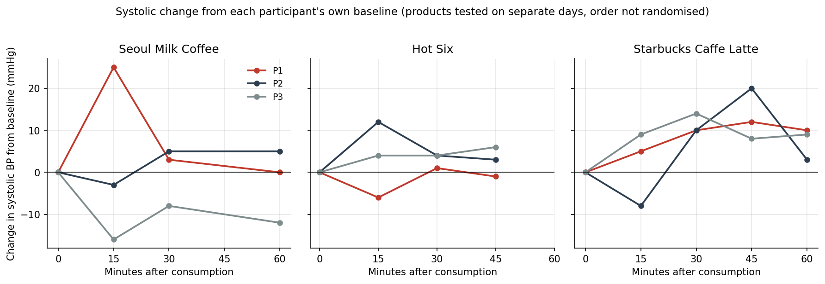
Figure 2
Largest change in systolic blood pressure recorded for each participant and product.
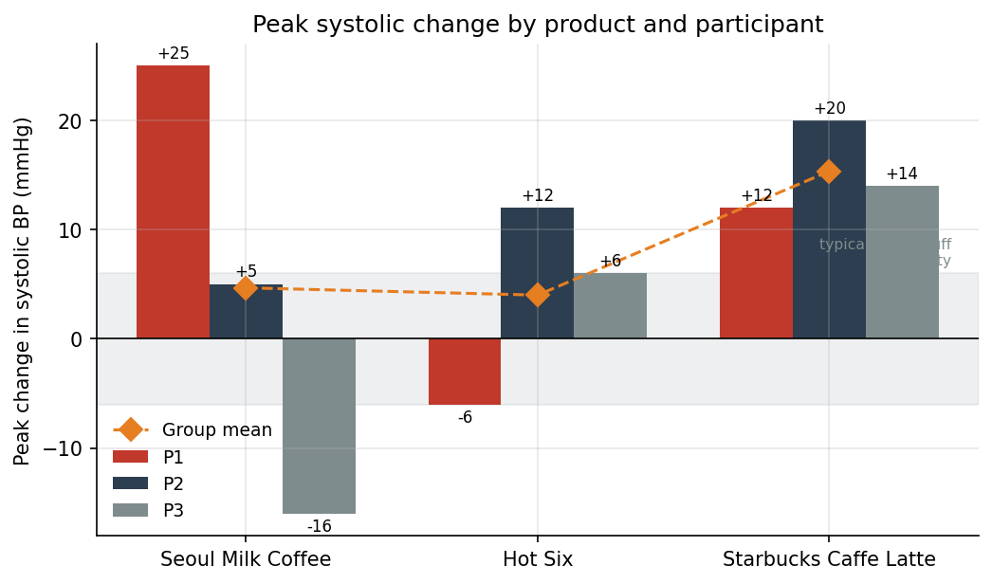
Figure 3
Change in pulse from baseline, by product and time.
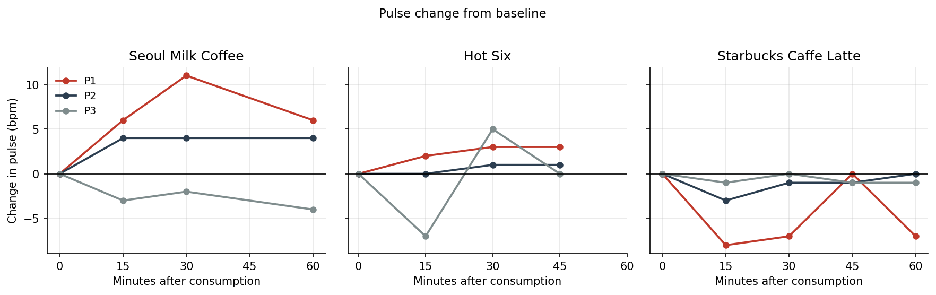
Figure 4
Change in diastolic blood pressure from baseline, by product and time.
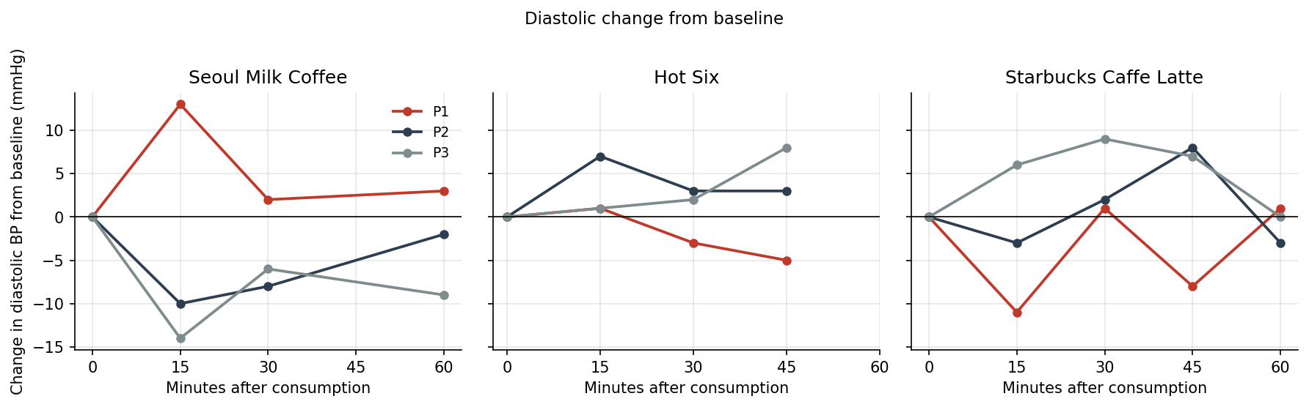
Figure 5
Resting systolic pressure of each participant before drinking, by session.
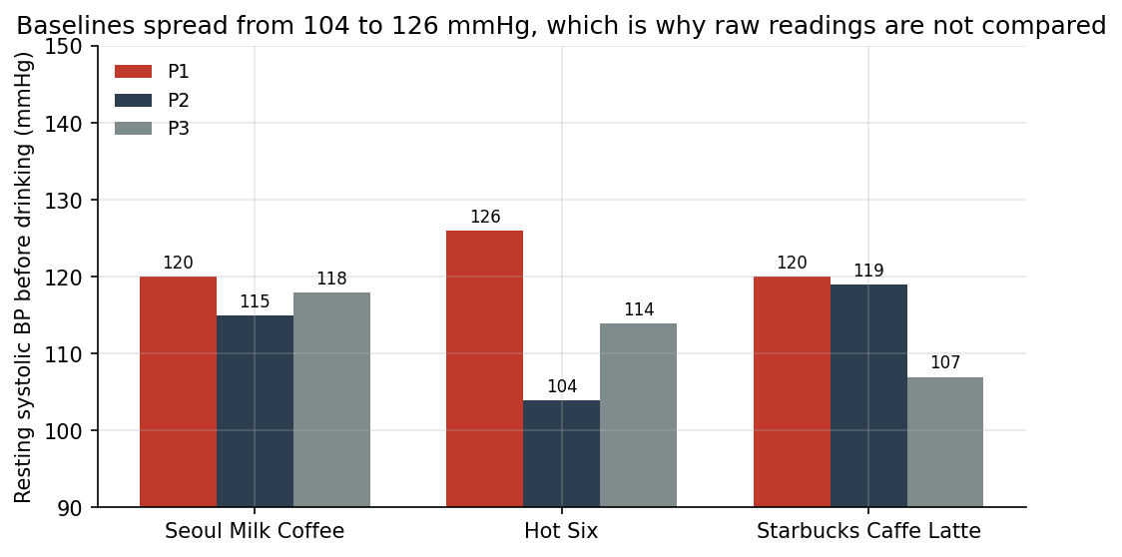
Figure 6
Caffeine and sugar delivered by 100 ml of each product, drawn from Table 1.
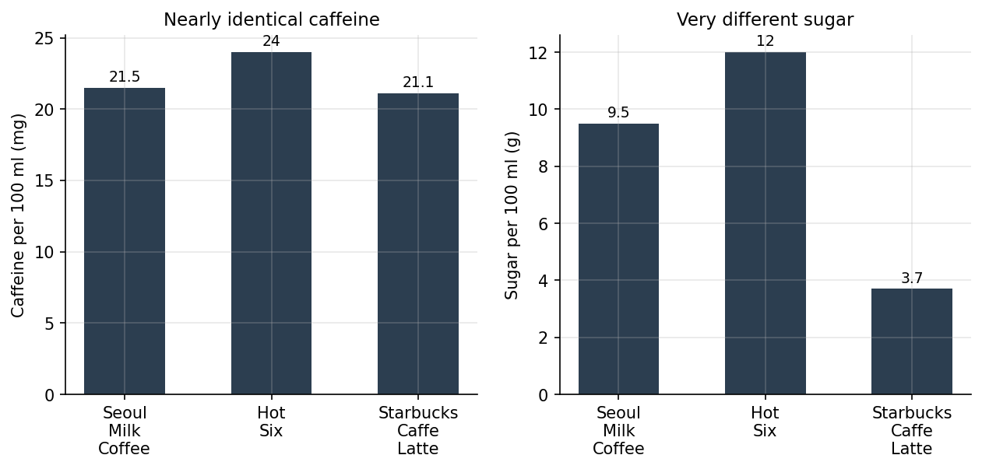
Figure 7
Time-weighted mean change in systolic pressure over the whole session.
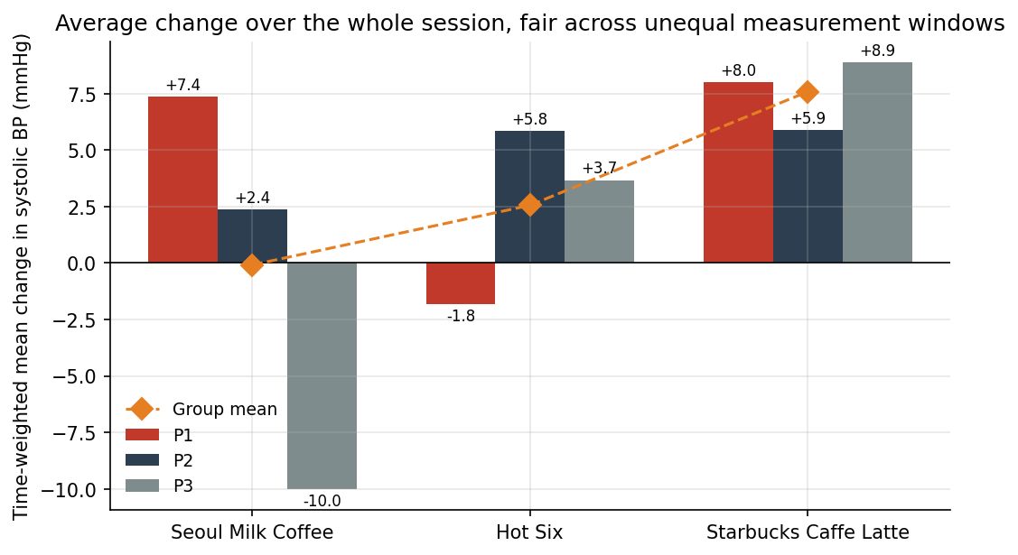
Figure 8
Peak systolic change for every participant and product in one grid.
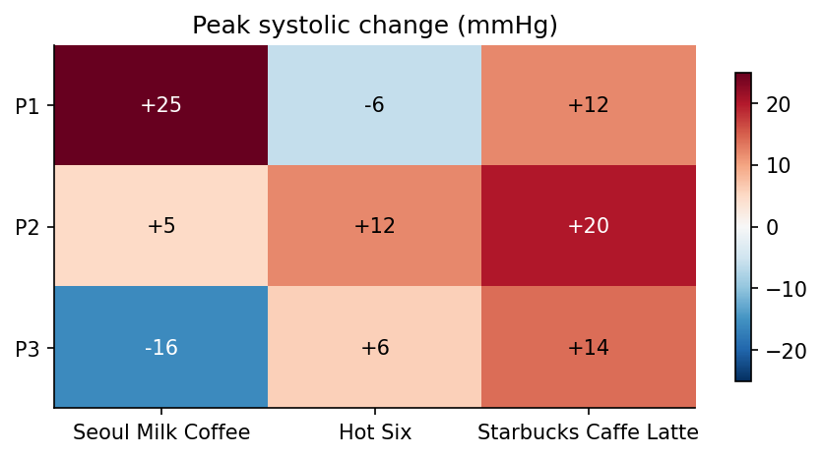
Table 3
Raw measurements recorded at each time point.
Product | Time | P1 SYS/DIA/PUL | P2 SYS/DIA/PUL | P3 SYS/DIA/PUL
Seoul Milk Coffee (Feb 15) | Baseline | 120 / 59 / 50 | 115 / 75 / 57 | 118 / 69 / 68
 | 15 min | 145 / 72 / 56 | 112 / 65 / 61 | 102 / 55 / 65
 | 30 min | 123 / 61 / 61 | 120 / 67 / 61 | 110 / 63 / 66
 | 60 min | 120 / 62 / 56 | 120 / 73 / 61 | 106 / 60 / 64
Hot Six (Feb 17) | Baseline | 126 / 62 / 58 | 104 / 67 / 61 | 114 / 66 / 67
 | 15 min | 120 / 63 / 60 | 116 / 74 / 61 | 118 / 67 / 60
 | 30 min | 127 / 59 / 61 | 108 / 70 / 62 | 118 / 68 / 72
 | 45 min | 125 / 57 / 61 | 107 / 70 / 62 | 120 / 74 / 67
Starbucks Caffe Latte (Feb 18) | Baseline | 120 / 68 / 63 | 119 / 75 / 59 | 107 / 61 / 68
 | 15 min | 125 / 57 / 55 | 111 / 72 / 56 | 116 / 67 / 67
 | 30 min | 130 / 69 / 56 | 129 / 77 / 58 | 121 / 70 / 68
 | 45 min | 132 / 60 / 63 | 139 / 83 / 58 | 115 / 68 / 67
 | 60 min | 130 / 69 / 56 | 122 / 72 / 59 | 116 / 61 / 67
Summary of Key Results
To summarize, the results of the experiment have shown that the three products had almost the same caffeine but not the same responses at all. Hot Six got an alertness score more than three times higher than the Seoul Milk Coffee, which follows the image of the products and not the label, but the blood pressure actually moved the most after the latte, and the drink with the highest alertness score moved it the least. The pulse stayed flat for all three. The differences between participants suggest that regular caffeine consumption does influence the responses.
Discussion
Interpretation of Results
From this research, it has been known that caffeine effects are dependent on the genetic metabolic rate, tolerance developed from habits, and the type of product consumed. What this study adds is that the caffeine content itself was not one of these differences. Because 100 ml of each beverage contained between 21.1 and 24.0 mg, the caffeine variable stayed almost the same in all three conditions, so any difference in the responses must have come from something else.
The clearest difference is the perceived alertness. The participants rated the energy drink at 9.0 and the milk coffee at 2.66 after drinking almost the same amount of caffeine, and a gap of 2.5 mg cannot make a three times difference in stimulation. What separates these two products for the person drinking them is not the ingredients but the category, as one is sold as a stimulant with alertness marketing while the other is a common milk drink. The rating followed the category.
Sugar and taurine also cannot explain this pattern. The energy drink had the most sugar at 12.0 g per 100 ml and it is the only product with taurine, but it produced the smallest measured change, while the latte had the least sugar and produced the largest. Both ingredients go in the opposite direction of the measured response.
The pulse result is also a finding, not just an absence. The systolic pressure changed while the pulse did not, in every participant and for every product. A rise of blood pressure without a rise of heart rate is the sign of the blood vessels tightening rather than the heart beating harder, which matches what is known about caffeine at this dose size.
Comparison with Previous Studies
The findings of this study correlate with the existing studies that had researched caffeine's tolerance and metabolic differences for men and women. This research fits into the broader literature of caffeine as it dives deeper into the range of caffeine products. Currently, there are not a lot of studies that include different products like energy drinks in their experiment, while this study completely reviews and gets through these multi-stimulant drinks for further discussion.
This study is different from those works in one point. The published guidance treats the caffeine dose as the main variable, but here the dose was the same across the three drinks and the reported effects were still very different. Rauf et al. (2025) found that caffeine use is shaped by media and social context instead of being equal across people, and the data of this study extends that idea from how much people drink to how strongly they feel it.
From this data, it can be concluded that the product a person believes to be stimulating and the product that actually changes their blood pressure are not the same product. Because only one adolescent took part in this study, the age question is left for a larger study.
Implication of Findings
This study carries a meaningful impact upon public health awareness, particularly with adolescents' caffeine consumption. In Korea, the high-caffeine warning is attached to products above a set concentration, which puts energy drinks inside the warning category and most coffee milks outside of it, even though the products in this study delivered the same caffeine per 100 ml. This means the warning system separates products that are actually similar, and the alertness data shows that the students' feeling of which drinks are stimulating already follows the label, not the content.
For example, a student who avoids an energy drink before an exam and drinks coffee milk instead did not reduce their caffeine at all. By Table 1, they actually took a little more per 100 ml, but the alertness scores suggest they would still feel much less stimulated. Because of this, printing the milligrams per serving on every caffeinated product would help adolescents more than the current warning category, since the chemistry does not support that category.
Limitations of the Study
Despite the usefulness of this study, there were weaknesses that left several notable limitations that affect the result and the generalizability of the findings. The number of participants consisted only of three, including two adult participants and one teenage participant, which is insufficient to draw broad conclusions that includes population-level responses. Caffeine dosage was also not standardized across product types, which were the Starbucks Cafe Latte, and Seoul Milk Coffee. Finally, the self-reported alertness was too subjective and it could have varied with the results itself. Plus, the absence of a controlled lab setting might have limited time period observation and restrict deeper conclusions to be drawn.
Plus, three more limitations come from the procedure. Each product was tested on a separate day in a fixed order, so the product effects and the day effects cannot be separated. Each reading was also taken only once, so the normal error of the monitor is about as large as the differences being examined. Finally, the participants knew which beverage they were drinking, which affects the alertness rating directly and may also affect the physiological readings through expectation.
Suggestions for Future Research
Future research should address the limitations of this study through diverse samples with similar caffeine concentrations, participants across a wider range, including age, genders, and caffeine tolerance. Longitudinal studies must track participants over several weeks to identify how strong these tolerances would be.
Also, the most direct next step comes from the main finding. Since the perceived stimulation followed the product and not the dose, the next experiment is to hide the product, by pouring the same three drinks into identical cups and running the alertness scale again. If the three times gap disappears in that test, then the expectation was making the gap. Some smaller fixes should be added too, like changing the order of the drinks for each participant, taking each reading two or three times after sitting still, and asking the alertness score at every time point instead of once at the end.
Conclusion
Summary of Key Findings
This study reviewed the comparative physiological reactions to coffee and energy drinks for individuals with different ages and tolerance levels. From this research, it has been found that the three beverages contained the same caffeine per 100 ml but still produced very different results. The alertness score of the energy drink was the highest and the milk coffee was the lowest, with more than a three times gap between them, while the latte sat in the middle. However, the blood pressure went in a different order, as the latte made the biggest peak change of +15.3 mmHg while the other two drinks stayed inside the error range of the monitor. The pulse did not change for anyone.
From these results, three conclusions can be made. First, in this sample, how a drink felt was decided by which drink it was, not by the caffeine inside it, because the caffeine inside was the same for all three. Second, feeling stimulated and being measured as stimulated are two different things, and they did not match in this study. Third, in this small sample, caffeine at around 20 mg raised the blood pressure while leaving the heart rate alone, which points to the blood vessels rather than the heart.
Contributions to the Field
The findings of this study have lengthened the existing idea of caffeine research by providing a product-comparative analysis that differentiates coffee from energy drinks as a separate stimulant source. The contribution of this study is the caffeine figure per 100 ml for each product, which comparative research in this area usually does not report. When the dose is fixed and equal, whatever difference remains has to come from the product itself and the expectations attached to it. Another point worth reporting is that the same measurements, read as raw values, put the energy drink first, but read as the change from each participant's own baseline, they put it last. The analysis method decided the answer.
Practical and Theoretical Implications
These findings reinforce the importance of product-specific caffeine guidelines, but not in the usual direction. The three beverages in this study fall on different sides of the Korean high-caffeine warning line, even though they give the same dose. So writing the milligrams per serving on every product would inform the consumers better than the category itself. Also, the results support the conceptual framework in the literature review, which includes product type, genetics, and habitual consumption as factors that shape individual responses. However, these three factors cannot explain a three times gap of reported alertness at the same dose. The gap may reflect the expectation of the drink, which is built by the marketing and the label, so expectation should be added to the framework as the fourth factor.
Recommendations for Practice, Policy, or Action
- First, public health organizations should write the caffeine in milligrams per serving on the front of all caffeinated beverages, including the coffee milks that are under the high-caffeine warning line, because the products in this study delivered the same dose with different labels.
- Second, the guidance for adolescents should be organized around the milligrams consumed per day, not around the product categories, because changing an energy drink to coffee milk does not lower the intake per 100 ml.
- Third, future researchers should prioritize larger, controlled, and specific studies that include all the variables included in limitations of study that build a strong specific idea of individual caffeine sensitivity.

References
Liu, X., & Xu, S. (2026, February 2). Unraveling the complexities of caffeine: Metabolism, genetics, evolution, and health. Hereditas, 163, Article 36. https://doi.org/10.1186/s41065-026-00648-z
Mayo Foundation for Medical Education and Research. (n.d.). Caffeine: How much is too much? Mayo Clinic. https://www.mayoclinic.org/healthy-lifestyle/nutrition-and-healthy-eating/in-depth/caffeine/art-20045678
Rauf, M. Q., Sharma, L., Essiet, E., Elhassan, O., Fahim, R., Irem-Oko, F., & Sreedharan, J. (2025, June 17). Caffeine consumption patterns, health impacts, and media influence: A narrative review. Cureus, 17(6), e86215. https://doi.org/10.7759/cureus.86215
Seoul Metropolitan Government. (n.d.). The truth about coffee milk [In Korean]. Seoul Media Hub. https://mediahub.seoul.go.kr/archives/1094296
Soliman, M. (2026, June 7). 8 symptoms of caffeine withdrawal. Healthline. https://www.healthline.com/nutrition/caffeine-withdrawal-symptoms
U.S. National Library of Medicine. (n.d.). Caffeine. MedlinePlus. https://medlineplus.gov/caffeine.html
U.S. National Library of Medicine. (2026, April 17). Caffeine in the diet. MedlinePlus. https://medlineplus.gov/ency/article/002445.htm
Van De Walle, G. (2020a, May 8). Caffeine tolerance: Fact or fiction? Healthline. https://www.healthline.com/nutrition/caffeine-tolerance
Van De Walle, G. (2020b, March 19). What is a caffeine crash? Plus 4 tips for how to avoid it. Healthline. https://www.healthline.com/nutrition/caffeine-crash

